Q1
- Node<String> head = null;
Node<String> tail = null;

head=new Node<>(“a”);
tail = head;

tail.next = new Node<>(“z”);
tail= tail.next ;

z
a
Next : null
next

c) current = head;
current.next;
d)
firstNodee
z
a
next
next: null
next

e) the firstNode will become the first node , the a node will become the second one and the node that have “z” element will become the last node.

f) public void addFirst(E e) { public void addFirst(E e) {
Node<E> firstNode = new Node<>(e);
firstNode.next = head;
head = firstNode;
size++;
if (tail == null)
tail = head;
}
g) head= firstNode;
h) 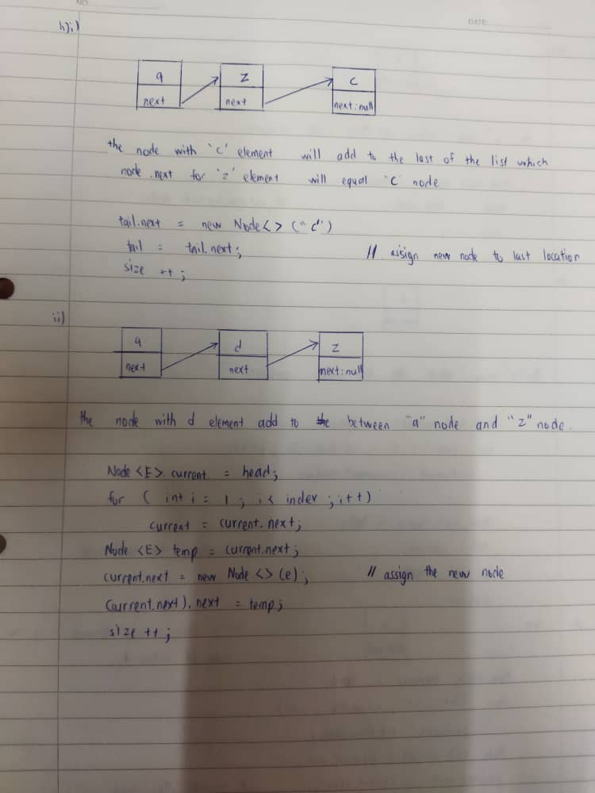
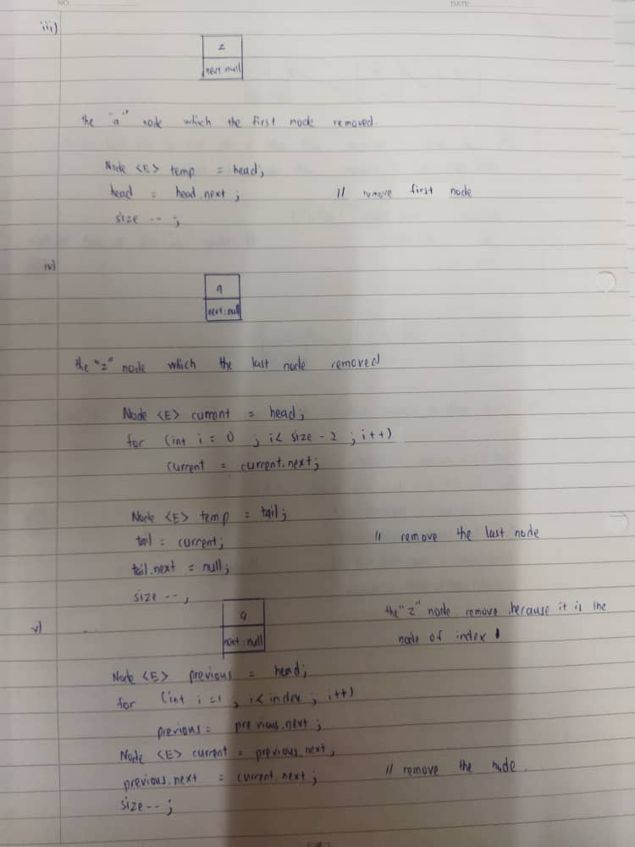

2)
public void containOf(E e) {
Node<E> pointerB = head;
for(int i=0; i<size; i++) {
if(pointerB.element == e) {
System.out.println(pointerB.element);
return true;
}
pointerB=pointerB.next;
}
return false;
}

3)
a) removeLast
b) Node<E> current = head;
for(int I =0 ; i<size -2 ; i++)
current = current.next;
Node<E> temp =tail;
tail =current;
tail.next = null;
size--;

